NKJV
Scripture taken from the New King James Version®. Copyright © 1982 by Thomas Nelson. Used by permission. All rights reserved.

The fear of the Lord is the beginning of wisdom.

But I keep under my body, and bring it into subjection: lest that by any means, when I have preached to others, I myself should be a castaway. Dry Fasting.

I know your works: you are neither cold nor hot. Would that you were either cold or hot! So, because you are lukewarm, and neither hot nor cold, I will spit you out of my mouth".

If a man has faith and not works will his faith save him? Even the demons tremble and believe.

Work out your Salvation with fear and trembling.

But he that does the will of my Father. -And by this we know we have come to know him, if we keep his commandments

When my people see judgment then they will learn righteousness.

God is not mocked for whatsoever a man sows he will reap.

Do you not know that the unrighteous will not inherit the kingdom of God? Do not be deceived. Neither fornicators, nor idolaters, nor adulterers, nor homosexuals, nor sodomites, nor thieves, nor covetous, nor drunkards, nor revilers, nor extortioners will inherit the kingdom of God

Many will tell me in that day, 'Lord, Lord, did not we prophesy in your name, in your name cast out demons, and in your name do many mighty works? He didn’t say they acted like they did, they did. A devil can’t cast out a devil.

No one can call Christ Lord but by the Holy Ghost.
don’t call him Lord make him Lord,

why do you call me Lord but do not do the things that I say?

If God didn’t think twice about taking pruning shears to the natural branches, why would he hesitate over you? He wouldn't give it a second thought

I preached that they should repent and turn to God and demonstrate their repentance by their deeds

Those who endure to the end shall be saved not once saved alway.

Who is angry with his brother IS in danger of judgment, who says fool is in danger of hell fire

For if after they have escaped the pollutions of the world through the knowledge of the Lord and Saviour Jesus Christ, and they are again entangled therein, and overcome, the latter end is worse with them than the beginning.

For it had been better for them not to have known the way of righteousness, than, after they have known it, to turn from the holy commandment delivered unto them.

But it is happened unto them according to the true proverb, The dog is turned to his own vomit again; and the sow that was washed to her wallowing in the mire

There is sin that does not lead to death
Dogs Hypocrites Lukewarm will not inherit the kingdom

You can't cast out devils unless you know Jesus like the people who were attacked by devils trying to use his name. But Jesus said some will cast out devils and be said to depart.

Let nothing be exalted above the command of God, Heed the warnings

If my people who are called by my name humble themselves, and pray and seek my face and turn from their wicked ways, then I will hear from heaven and will forgive their sin and heal their land.

They honor me with their lips but their hearts are far from me, so I have given them a spirit of slumber and their eyes do not see.

Whos condemnation is just?

Those that defile the temple shall be destroyed

The wicked will be taken in their iniquity

If our hearts condemn us we have no confidence before God

Gladness of calamity will not go unpunished

there are consequences even though you're forgiven
If you do not forgive others God will not forgive you
When you stop judging yourself it’s because you truly have stopped judging others

By Your words you will you be acquitted or condemned,

If man regards sin in his heart God will not hear

///////////

The Lord reveals his secrets to those who fear him

I wait for the Lord, my whole being waits, and in his word I put my hope

Music helps still your mind

Enter with praise and thanksgiving

Be still and know, those that wait on the Lord shall renew their strength = enter presence

He inhabits the praises of his people

If we are ashamed of him he will be ashamed of us

—--------------------------
Jubilee, Passover
Ephesians 1, Jeremiah 33:3, Psalm 73
Free give you have freely received, expect nothing in return, a laborer is worthy of his wages ny God
King Herod was struck down by an angel for not giving glory to God
To whom shall we go Lord, you have the words of life.

Where many are gathered together prayer is more powerful

Plans without counsel fail with many advisors they succeed, zeal without knowledge

Who argues with a fool is one himself
The mercy you give others will be given back

Shall not tempt God.
Men shall not live by bread alone but by every word of the mouth of God.
Shall worship and serve God only.
God is in control and always make a way of escape
Buy a sword, a slap on the cheek means only an insult

patience means waiting without complaining

patience with others is love, be as patient with others as God is with you
patience with yourself is hope, let your hope keep you joyful
patience with God is faith, don’t judge God’s ways while they are in progress

One person's pain is as nothing when compared to the suffering of all

Samuel presumed that it wasnt David to be king, but that doesn't make Samuel a false prophet
///////////////

Behold I have given you all power over the enemy and by no means shall anything harm you

Who honors God he will honor and those who do not will be lightly esteemed.

You won’t know what God can do with your broken pieces until you give them a chance.
Let the ignorant be ignorant still

Michael said to Helel may the Lord rebuke you

~Honor God with the first fruits of your storehouse and your barns will be filled with plenty
~Who considers the poor God will deliver in a time of trouble
~Who gives to the poor lends to the Lord and he will repay him for what he has done
~~Honor your parents that it may go well with you

-Do unto others as you would have done unto you

-Submit unto God resist the Devil and he will flee
—————————————————
Enemies
-As for those who persist in sin, rebuke them in the presence of all, so that the rest may stand in fear.
-Declare these things; exhort and rebuke with all authority. Let no one disregard you.

Outsiders
For what have I to do with judging those also who are outside? Do you not judge those who are inside? But those who are outside God judges. Therefore “put away from yourselves the evil person.”
(Expose and Warn)

-He will guide you into all truth,

Who does not love does not know God for God is love

Greatest of all is servant of all, without love i gain nothing

He giveth him inspiration
All scripture is given by inspiration

Prophetic instruction gives faith to act

//////Become all things to all people that i might win them

—————

Let no man glory in men number1

Thus saith the Lord, Let not the wise man glory in his wisdom, neither let the mighty man glory in his might, let not the rich man glory in his riches:
But let him that glorieth glory in this, that he understandeth and knoweth me, that I am the Lord which exercise lovingkindness, judgment, and righteousness, in the earth: for in these things I delight, saith the Lord.

-I will stand upon my watch, and set me upon the tower, and will watch to see what he will say unto me, and what I shall answer when I am reproved.

Habbakuk 2:1

-All things are possible to those that believe (meditation)

-Let the peace of God rule in your hearts
(Bubble spontaneous effortless / Boil gradual injectory)

Strong / Unpeaceful

Enter into his gates with thanksgiving

Can't hear the Spirit unless you are in the Spirit/love

Seek him first and the rest added (Visitation Prayer)

——————

The anger of man does not produce the righteous purpose of God,

Outsiders that behave as insiders are judgeworthy like witchdoctors like Paul struck sorcerer blind

Martyrdom is out of obedience not carelessness

(Suffering)Though he slay me i will trust in him,

Be not a surety of debts
God does not owe us anything
Render unto Caesar that which is Caesar’s

//////

He that hath clean hands, and a pure heart; Who hath not lifted up his soul unto vanity, nor sworn deceitfully. He shall receive the blessing from the LORD, And righteousness from the God of his salvation

God is willing to give us all things pertaining to life and godliness, the love that brought Jesus, and helps you and me to believe

Your faith is as good as your emergency
Check yourself before you check God
Jesus looked past my faults and saw my need

“The righteous cry out, and the LORD hears them; he delivers them from all their troubles. The LORD is close to the broken hearted and saves those who are crushed in spirit.”

David said “I shall trust in his mercy”

According to the proverb 'God helps those who help themselves, God helps those people who work on their problems and

never cuss their bad luck or blame others for their problems.

Put God first and he will put you first

Devote yourselves to prayer, being watchful and thankful. - Colossians 4:2

[ Tell people about Jesus while meeting their needs

be it unto me according to your word
be it unto you according to your faith
consider to be

Beloved, I wish above all things that you be in health and prosper even as your soul prospers

Work smarter not harder

///////////////////////////////////////////////////////////////////

pray for laborers to harvest because there are few,
for leaders that you may live peaceable lives,
for Jerusalem for as goes Jerusalem so goes the world,
for the church to mature, and be equipped
for minimization of evils
for salvation of others
etc
And pray in the Spirit on all occasions with all kinds of prayers and requests. With this in mind, be alert and always keep on praying for all the Lord’s people. Pray also for me, that whenever I speak, words may be given me so that I will fearlessly make known the mystery of the gospel, for which I am an ambassador in chains. Pray that I may declare it fearlessly, as I should.

Trust in God that you may be established, trust his prophets that you may prosper
be anxious for nothing but in everything prayer supplication with thanksgiving let your requests be made known and the peace of God that surpasses all understanding will guard your hearts and minds by Christ Jesus
Fight the good fight if faith victory
////////////////////////////////////////////////////////////////////////////////////////////////////////////////////////////
///////////
Speaking of did ya, going to do, doing now, is done
////////////
behold i have given you all power over the enemy and by no means shall anything hurt,
Know they hated Christ before they hated you

stay in your lane

the feast of trumpets
the day know man knows because its a two day event

////////

Everything is a coincidence or nothing is, and nothing is
0+0=0, 1 way to Heaven

Steady pressure breaks the yoke

///////
How much more will he take care of you o little faith
he will do it again
Be specific about your requests

///
God makes it to rain on the just and the unjust, if God said love your enemies surely he will love me also
The Lord is my helper, lullaby
—————————————
Clean water is Clear
When less is actually more
find the truth before it's too late
——-
Lifting your hands in praise is synonymous to how Moses lifted his hands

You've come looking for me not because you saw God in my actions but because I fed you,
Beloved, now are we the sons of God, and it does not yet appear what we shall be: but we know that, when he shall appear, we shall be like him
Which is easier: to say, 'Your sins are forgiven,' or to say, 'Get up and walk'?

No impress, prove, control
Don't write off or make fun of
Red herring, gaslighting, filibuster
Apologetic, indifferent, practicing
Don't throw rocks or you'll be next

Now Lord consider their threats and enable your servants to speak your word with great boldness. Stretch out your hand to heal and perform signs and wonders through the name of your holy servant Jesus
///
Follow the main thing ask everyday what is the main thing, obey the outcome God let you choose along way

The past will never see the future discounting bad memory
My God shall supply all your need

Blessed are ye, when men shall revile you, and persecute you, and shall say all manner of evil against you falsely, for my sake. Rejoice, and be exceedingly glad: for great is your reward in heaven: for so persecuted they the prophets which were before you.

love is the bond of perfection,

Fasting does not count if it’s in your own ways and pleasures, if you regard sin

Seek Jesus and you will find faith
When you truly know how much you are loved you won't beg
God makes it rain on the just and the unjust

All that call upon the name of the Lord shall be saved
Whatever you ask in my name i will do it that the father may be glorified in the son

KNOW HIS JUDGEMENTS

(Sowing, Worship)
Give ⅕ test God with charity, there is one who waters another but himself is watered and grows, yet there is one who waters only himself and does not grow, stretch out to God and he will stretch out to you, give and it shall be given unto you pressed down shaken together and running over
You have robbed God in tithe and offering

(Gifts, being led)
Interpretation of tongues is the only Biblically consistent way of hearing the words of God, seeing pictures and visions often leave you wondering what they mean and can sometimes be false imaginations if you aren't careful, God doesn't promise us to audibly speak to us, although he technically could, but you have the power to interpret what he is saying through you
A thought strong enough to stand out
Let each one prophecy according to their faith, tongues is faith so is interpretation, it starts to fill your mind when you draw on it instantaneously
Tongues helps you to draw upon the Spirit
Draw up but don't try to make it up
Bright
You are speaking what you are hearing by faith instantaneously
—

As you are, as your word says, so shall it be
Stay on God’s side permanently

ABOVE ALL….. FROM ESCAPISM… GUARD YOUR HEART FOR OUT OF IT FLOWS EVERYTHING….
BURDENS OF SIN, PRESENT YOUR BODIES A LIVING SACRIFICE AS WORSHIP

Is the worse outcome really most likely or will it stay long?
/////////
Convicting Evidence is Faith not evidence
You cant have faith just because you want to
Crumb from the masters table is mustard seed
//////

Set a thief to catch a thief, what a thief stole was always expensive
If you truly were sorry for your sins you would have obeyed and forgiven as much as Christ forgave you, God will judge them you dont need to

Not ready to be lead until you are dead, even if i be killed Gods pleasing will be done, cannot inflate your own importance

Tongues is praying and agreeing with the perfect will of God and your investment of time will be measured back to you in opportunities and will clean alot of sin out of your life
All the promises of God are yes and amen
All that is required is met, by the Blood of Jesus

Cease from anger and forsake wrath; Do not fret it only causes harm. For evildoers shall be cut off; but those that wait on the Lord, they shall inherit the earth.
No weapon that is formed against thee shall prosper; and every tongue that shall rise against thee in judgment thou shalt condemn. This is the heritage of the servants of the Lord, and their righteousness is of me, says the Lord

Can not or will not

Ask for wisdom to fulfill your destiny and purpose and to guard your life from sin, Wisdom is a shelter as money is a shelter, but the advantage of knowledge is this: Wisdom preserves those who have it.

Who has more will be given.
Sow the wind, and you will reap the whirlwind.
Wash your thoughts with the word.

//
It is coming to pass as written, according to the nature, promise, and will of God because I do believe. The Lord is good to those who wait for him, to those who seek him. (Lament. 3:25)
//
Jesus did not pray in tongues he groaned in the spirit before raising Lazarus from the dead

“Whatever we ask according to his will, promise, nature we know he hears and we have the answer.”

“He that speaks in an unknown tongue speaks not to men but to God for no one understands him.”

“If any man speaks in an unknown tongue let him pray that he may interpret so he can be edified; - I will pray with the spirit and the understanding also.”

“Open your mouth and I will fill it.” Do not hesitate, “Let him prophesy according to his faith.”

the spirit of the prophets are subject to the prophets so someone can prophecy out of hatred and twist the message not all prophets are accurate and some prophecies can change do not take oaths know no man by the flesh
Practice long enough like martial arts, nobody gets it their first try
“Pray believing you receive them and you shall have them.”

“Don't pray to be seen. - Cease without praying.”

For all the promises of God are yes and amen

For the Lord is good to those who wait on him to those who seek him

With God all things are possible

God is not man that he should lie
//
How can vipers speak good things when they are evil

//
If you look closely at the two examples Jesus gave in the New Testament of great faith you will notice one was an upright man and one was was a wicked woman, both were gentiles not from the background of mosaic law, and they both stated examples of…
If that's the way it was that's the way it's gonna be
If that's the way God was that's the way God will be
The two people Jesus said had great faith both modeled that example, I don’t think it can get more sophisticated than that probably

Let your name be glorified
On earth as it is in heaven
//
Fear God's judgements, fearing God is fearing hell or death from him
Take up your cross and follow him (insignificant, worthless, unnecessary)
Dont judge unless you are positioned

Tongues Interpretation receives ideas to give requests

If you stay in praise you will stay in faith
Worship is mostly staying in holiness

//
Wait in tongues, Watch, night vision day precision
“You will keep in perfect peace those whose minds are steadfast on you,because they trust in you”

Praying is the main thing, praying is preparing for the future

Pray about it instead of taking it into your own hands

God never fails

//////
They assuming hypocrites entitled

//
That which has been is now, and that which is to be has already been; and God requires that which is past
God did it before so he will do it again hallelujah
His word is the sign that it’s working
I think people have trouble believing because they want to know exactly what will happen(trying to predict) instead of
‘something will change’ i just don't know how exactly
Waiting can be an act of faith
“The Lord is good to those that wait on him to those that seek him”
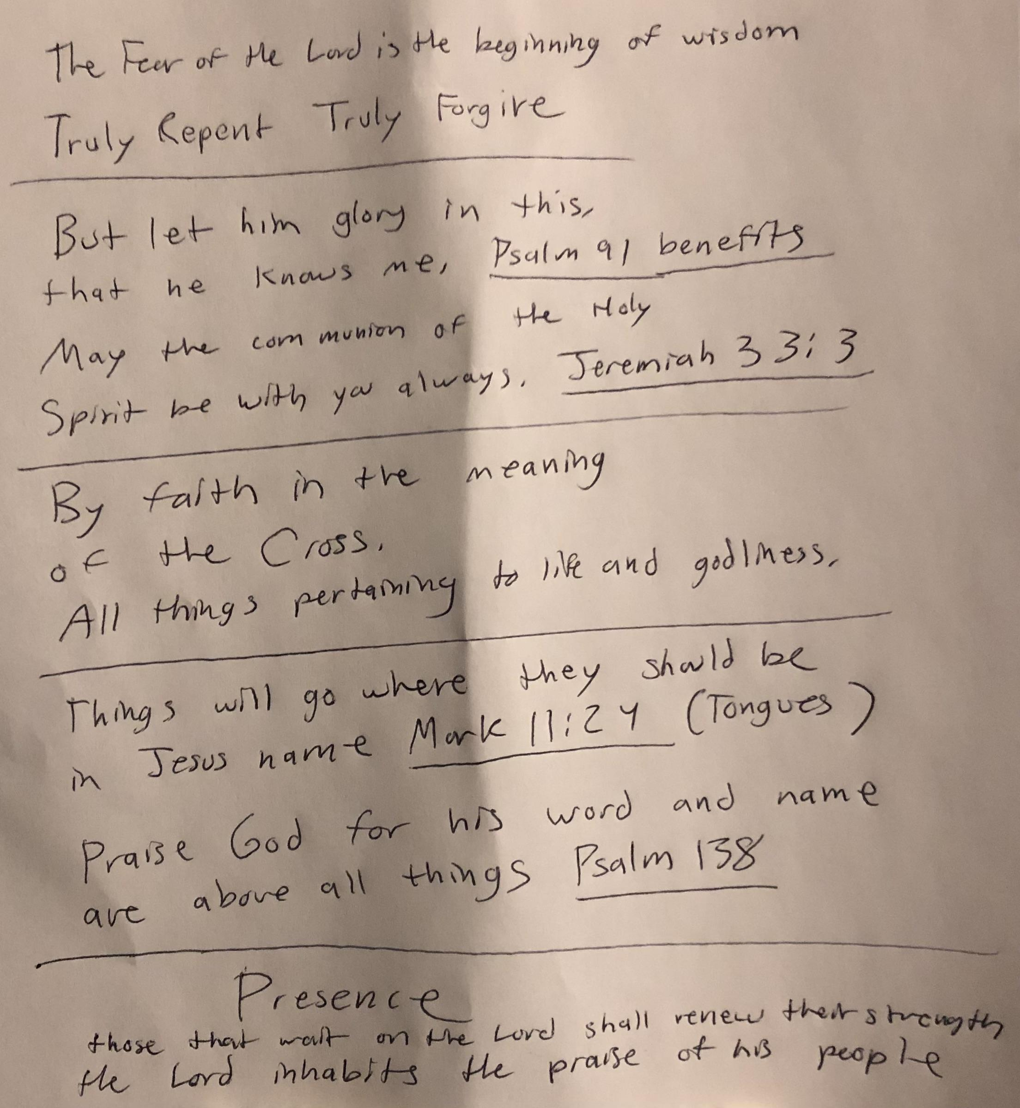

Cease without praying, don’t be a boiling frog

//////
The Lord is always good as in Heaven as he was on the Earth so I believe in Jesus name / he will do something about it (intercessory)
Prayer morning and night is the blood on the doorpost
///

Those that pray in tongues edify themselves
Jesus groaned in the Spirit he didn’t pray in tongues
The Spirit makes intercession for us with groanings
Not to say God can't use tongues mixed with faith for a miracle

///
Holy Ghost presence and filling / being upon is above all
Faith without presence/holiness is weak and slow
Jesus didn’t say sing or read the Bible before you go out he said tarry until you are endued with power
It isn’t some secret revelation of scripture it is the quickening of scripture by the Holy Spirit
It is not on you until it rubs off you, praying in tongues does not mean you are filled
Acts 1:8 is the key to the last days
Jesus didn’t accredit miracles to himself he said the Spirit of the Lord is upon me, your “faith” is not comparable to a Holy Ghost filled person, wisdom is to go were someone has it or get it yourself
Elisha wanted Elijah's spirit for the same reason
Sin separates and blocks you from your own conscious only repentance will fix your mind back in its place of functionality - the fear of the Lord is the beginning of wisdom
Seek the Lord with all your heart and you will find him - Jeremiah
I will call upon the name of the Lord so shall i be delivered from my enemies - Psalm

Thank you Lord that you hear our faith
Fasting isn't above Faith and Faith isn't above the Holy Spirit in terms of power
////
Better to end a conversation with no progress , interest agreement
Forgive them Father they know not what they do, make no charge against them
Those that will kill Christians think they serve a noble cause
Better not to laugh and be acceptable to God then to laugh at something unknowingly making yourself a scoffer
People focus on their lust and problems and wonder why they dont get anywhere look through the lens of his will
Do not boast about the future, if God wills you do this or that
//////

Greater is he that is in you than he that is in the world
Submit unto God resist the devil and he will flee
The Lord rebuke Satan

Praise God not because you are trying to believe or fit in
When you truly believe and are grateful you will not be afraid or embarrassed to thank and glorify God
If you really knew God was come through every time every day
That's why the early church was so bold

Brokenness is fuel to the fire
The heart is made better in sorrow
We see the destruction of lies &
We love him because he first loved us

If and when you do believe, praise God, it releases your faith
////////

Snakes use their tongue for direction (destiny)
Anti Danger - Time Factor

—————————————-

If a man regards sin in his heart the Lord will not hear as King Saul, you can't pray until you repent and forgive others (let go, flee, harmful opinion)

Fear the Lord and depart from evil, treat others how you want to be treated

There is sin that does not lead to death and yet the lukewarm and dogs will be cut off

If we confess our faults he is faithful and just to forgive us and cleanse us from all unrighteousness

——————————————

All that call upon the name of the Lord shall be saved

If you confess with your mouth Jesus is Lord and believe in your heart God has raised him from the dead you shall be saved

Vengeance is the Lord’s, we warn, have nothing to do with persistent evil, cast not your pearls before swine

——————————————-

Seek him first and all these other things shall be added until you, seek him with all your heart and you shall find him

Those that are the sons of God are led by the Spirit of God (test the spirits)

While the watchman slept the Devil entered; pray in tongues long enough and some interpretations (convictions) will be automatic

Who speaks in unknown tongues edifies himself and who groans in the Spirit intercedes (yield without pause)

——————————————-

Renew your minds and be filled with the Holy Ghost

You shall receive power after the Holy Ghost has come upon you not in you, Jesus already had the Holy Spirit in him for 30 years

——————————————

Cease without prayer (Psalm 91)

God is always righteous
God is not lazy he created the universe
God does not treat his children like orphans
It is God’s will so he will do something about it
Thank you Lord you hear our faith (release faith by praises)

Vision, Filled, Change

Beloved I wish above all things you may prosper and be in health even as your soul prospers; my God shall supply all your need

Atonement, Promise, Mercy, Authority

Intercession / Praying

Cease without Prayer / Psalm 91 (he that dwells)

God is always righteous and all powerful.
(God does not treat his children like orphans and he created the universe)
It is in God’s will, so something will happen

Waiting / Releasing Faith

Thank you Father you hear my faith in Yeshua’s name

Praise the Lord oh my soul and forget not all his benefits

(Authority, Promise, Mercy)

Beloved I wish above all things you may prosper and be in health even as your soul prospers; my God shall supply all your need

What time I am afraid I will trust in thee
————————————————

Edification / Watching

Who speaks in tongues edifies himself.
The Spirit makes intercession with groanings. (Roar) Jesus groaned in the Spirit
Who speaks in unknown tongues speaks not unto men but unto God for no one understands him.
If any pray in an unknown tongue let him pray that he may interpret.

Yield tongue and draw words out from your spirit/belly
(Without pause or hesitation / Let him prophesy according to his faith)

Do it long enough and some convictions/interpretations will be automatic

Practice long enough like martial arts, nobody gets it their first try

Holiness / Consecration

Present your bodies a living sacrifice Holy and acceptable unto God.

Be Holy for God is Holy.

If man regards sin in his heart the Lord will not hear as King Saul

There is sin that does not lead to death but the lukewarm and dogs will be cut off

Some go not out but by prayer and fasting

Repentance

If we confess our faults he is faithful and just to forgive us and cleanse us from all unrighteousness

Lord I confess my faults;
Falsehood/Endangerment
Stealing/Vainglory
Bitterness/Madness
Defilement of Holy things
Rejecting/Ignorance of what is right
I now let go and flee this evil/harm
I forgive that I may be forgiven
Iniquity is not optional remove it

Joy

The joy of the Lord is our strength
A servant is not above his master
Count it all joy when you fall into diverse trials and temptations
Vengeance is the Lord’s give warning
Have nothing to do with persistent evil, cast not your pearls before swine

Salvation

If you shall confess with your mouth Jesus is Lord and believe God has raised him from the dead you shall be saved

All that call upon the name of the Lord shall be saved

Go ye into all the world and preach the gospel unto every living creature

Build your house upon the rock (repent)

The Spirit

You can be obedient but you cannot make yourself righteous or powerful, we are vessels not self made

You shall receive power after the Holy Ghost has come upon you, the promise is to you

Not by might nor by strength but by the Spirit, why Elisha wanted Elijah's spirit

The Lord is good to those that wait on him to those that seek him

Seek him first and all these other things shall be added, seek him with all your heart and you shall find him

If any lack wisdom let him ask God who giveth liberally without finding fault and it shall be given him

“Life comes after you have been filled with the Holy Ghost, get down and pray for power” - Smith Wigglesworth

Uebert Angel
John Anosike - Roar, Immortality

Kevin Zadai - Praying from the Heavenly Realms

Tongues is for edification of your spirit
Fasting & Groaning is for intercession against strongholds

Prayer of requests
Prayer of faith in the blood bought promises
(Healing Salvation Direction Filling Needs)

Prayer of dedication

Psalm 23 /identity
Psalm 91/ name
The blood/ mercies
Healing wholeness salvation deliverance provision direction wisdom
The priests had to consecrate themselves before they could enter God’s presence/power (Fast atleast Lunch/Subdue the flesh)
Seek him with all your heart and you will find him
If man regards sin in his heart the Lord will not hear/ forgive,confess,remain
—
God is not a respecter of persons he will do it again
If I am evil and can do good then God will be good to me
There is enough grace for me
Shall he withhold any after giving his whole life?
Thank you Father you hear our faith
“Paul said; my God shall supply all your need”
“Peace, be still”
—
First things first
You shall receive power after the Holy Ghost has come upon you / filled with the Holy Spirit
(I believe there is a type of filling of the Holy Spirit by walking in the Spirit/in
But I also believe there is an intoxicating filling of the Holy Spirit how King Saul was and the Church that lacked boldness/upon)
Baptism of Fire / Rewire / New Heart
(If you abide in me…) no more sinfulness/harmful/burdens/unnecessary
Activate groan & tongues

If you aren't praying at least 4-6 hours a day you are wasting your life
Tongues -> English(Most important) -> Groaning
Conscious(Leading) -> Word -> Spirit
If i know something is wrong i will do it anyways but if i believe something is wrong i wont touch it
To think everything is fine when it isnt is the curse of hell, Paul says I obey my conscious dont put it away Gods law is written on everyones heart
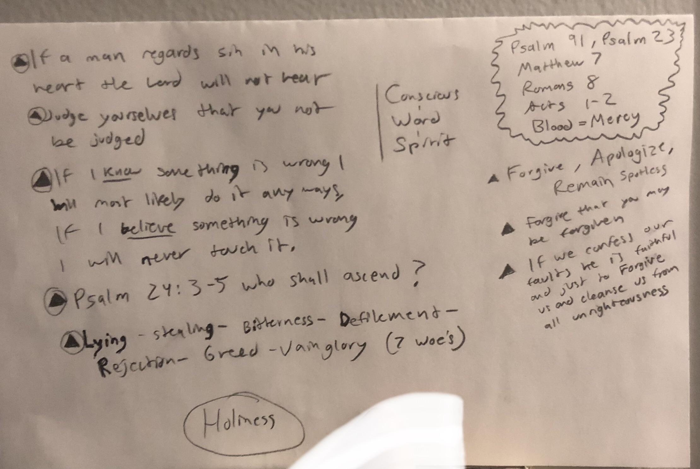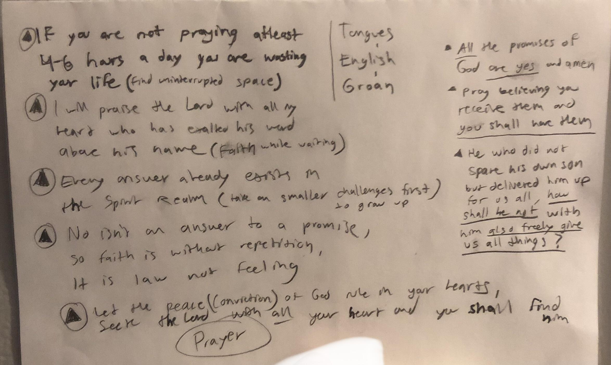
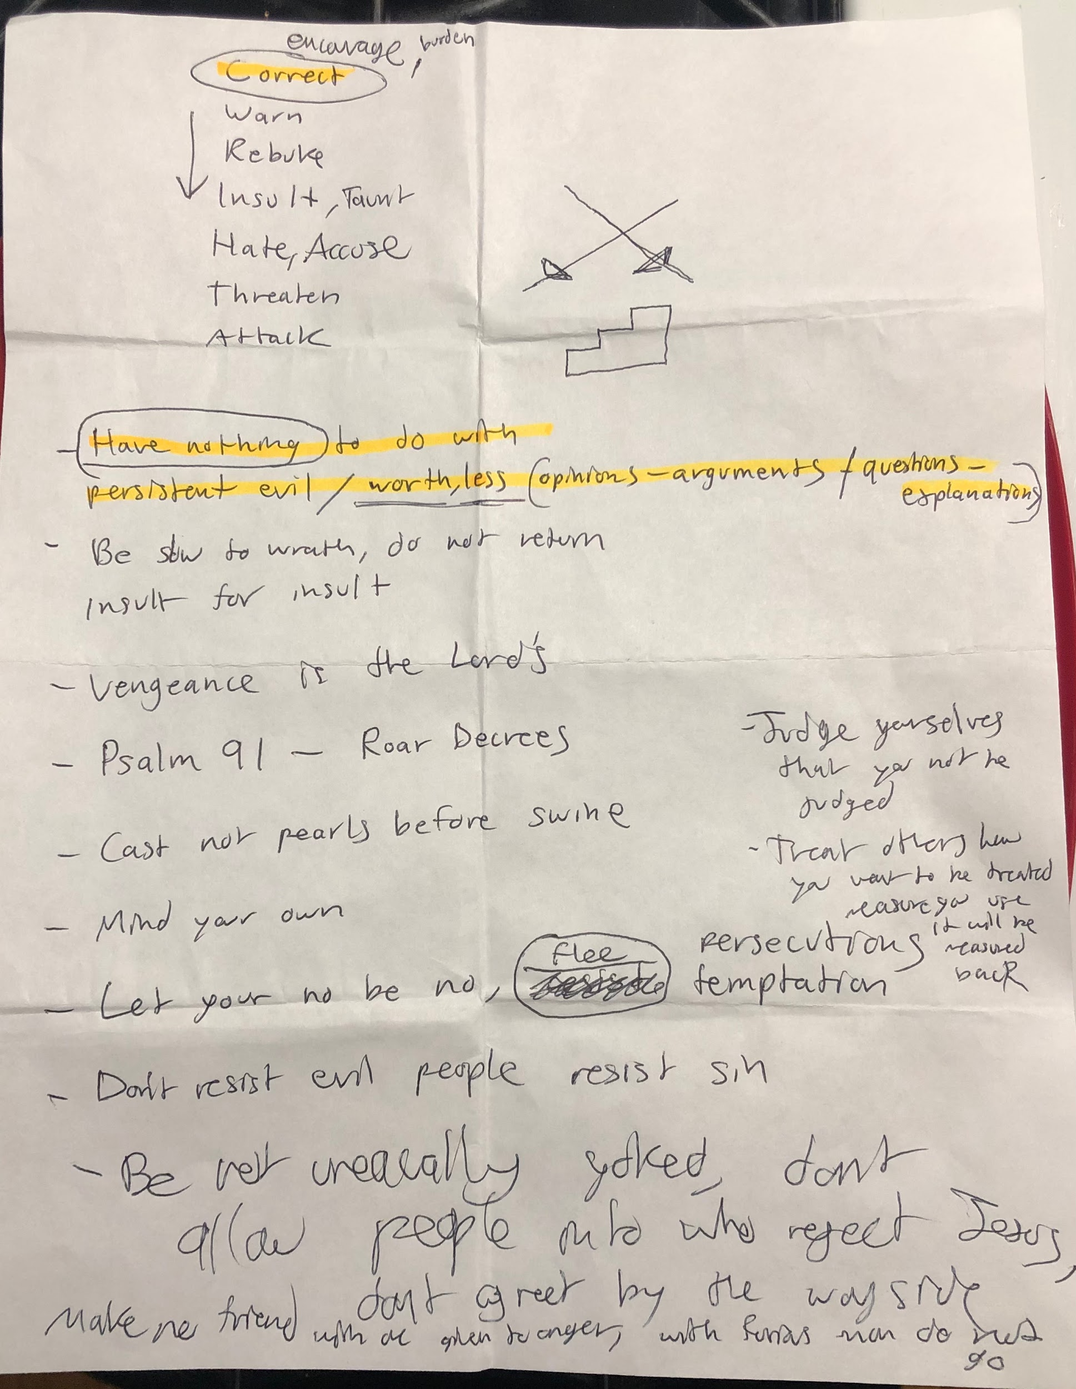
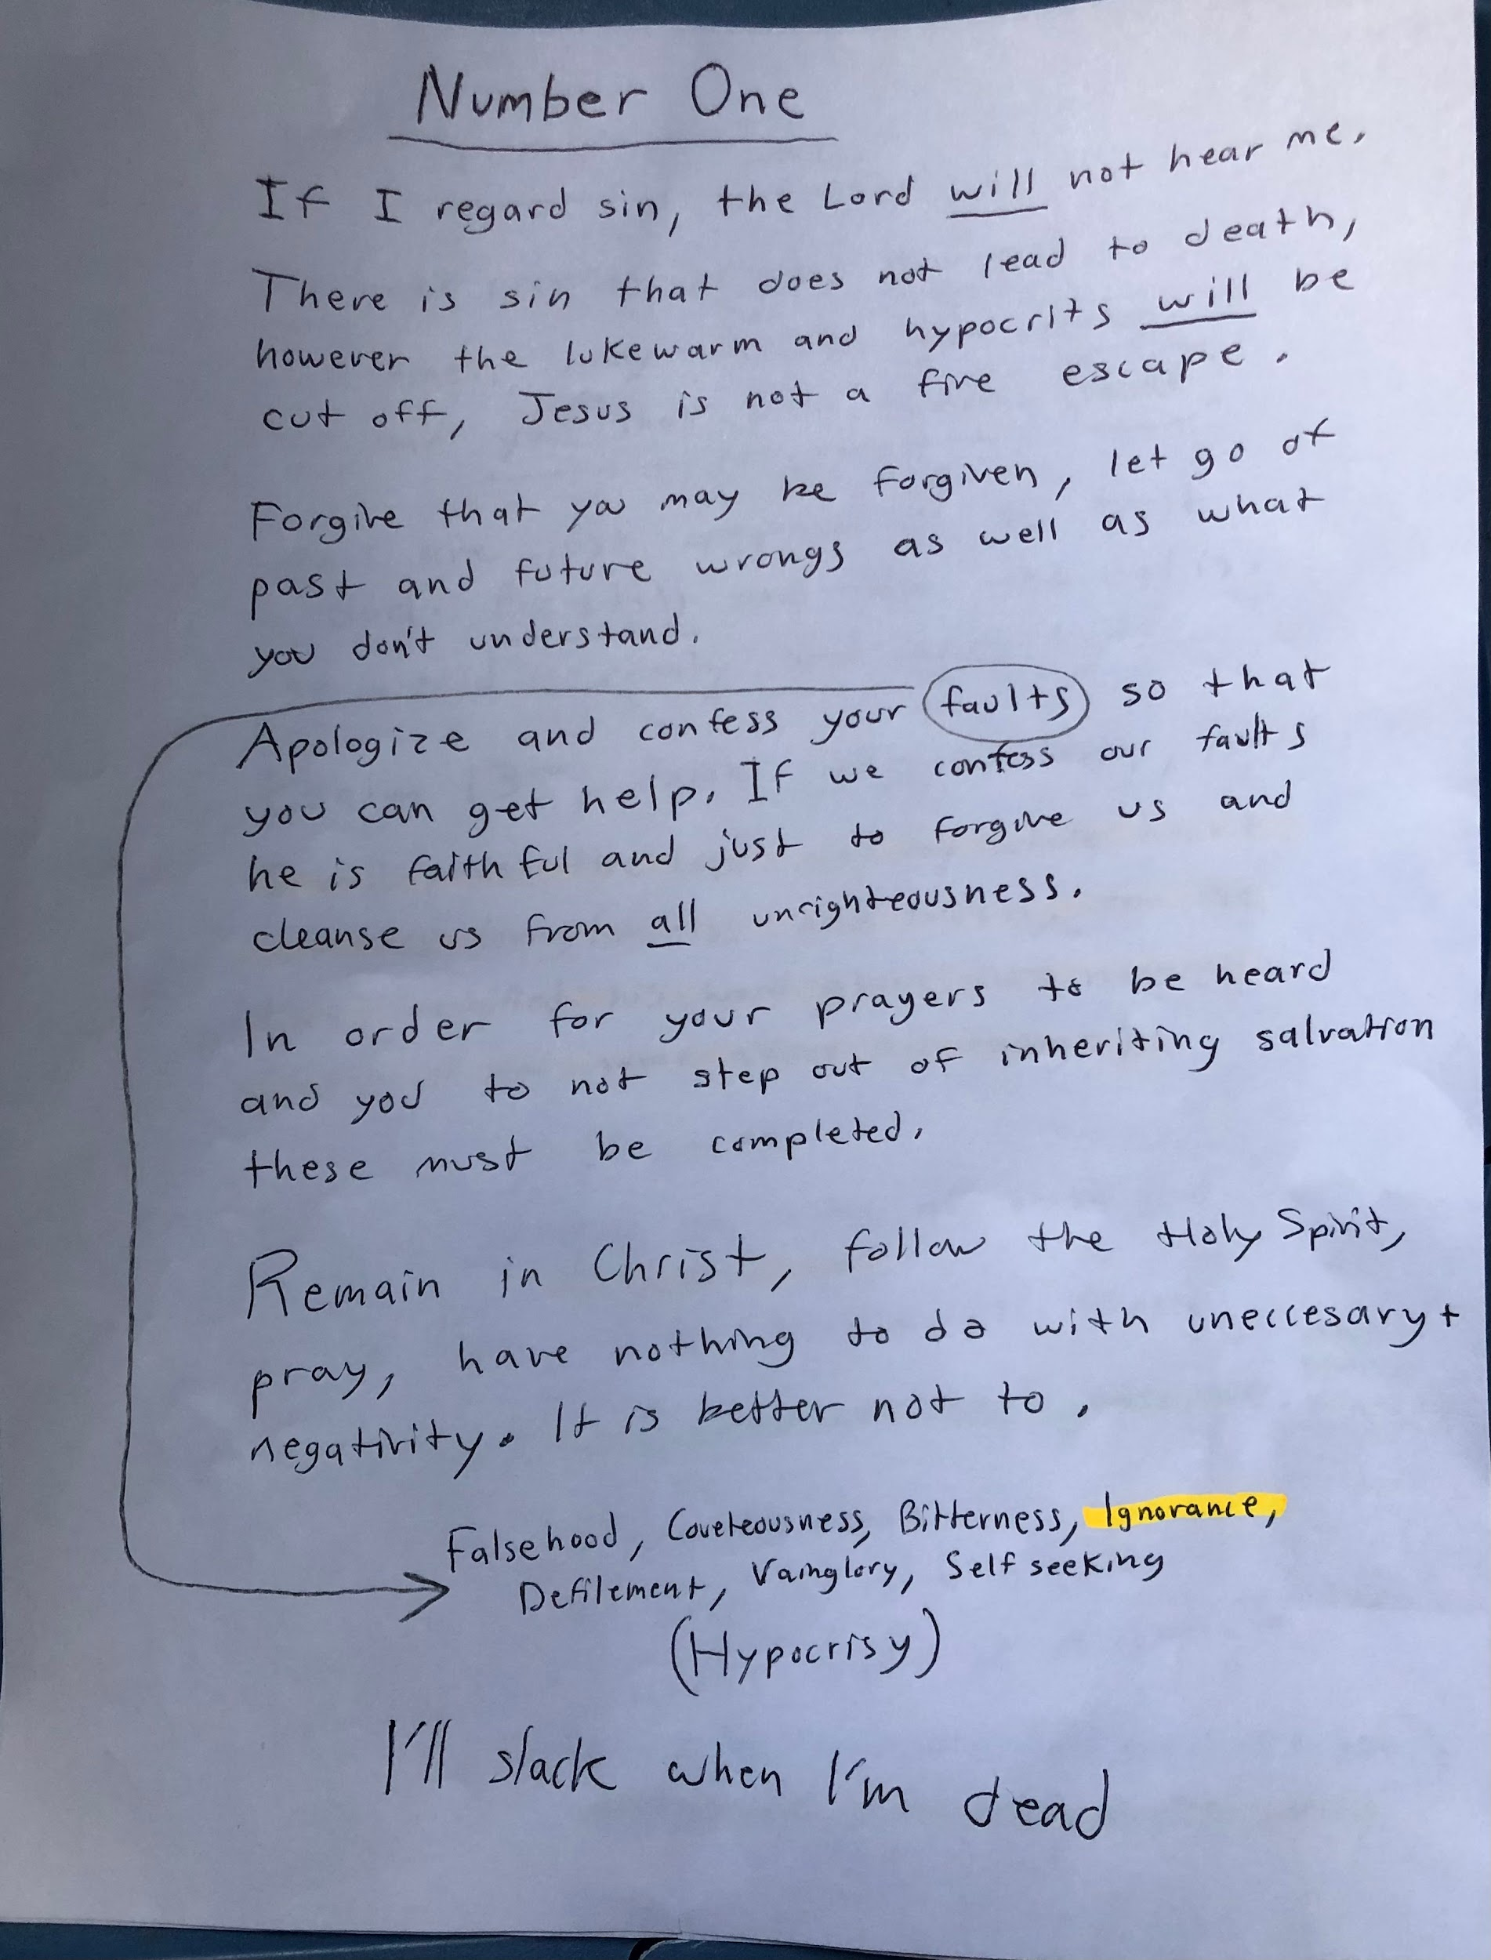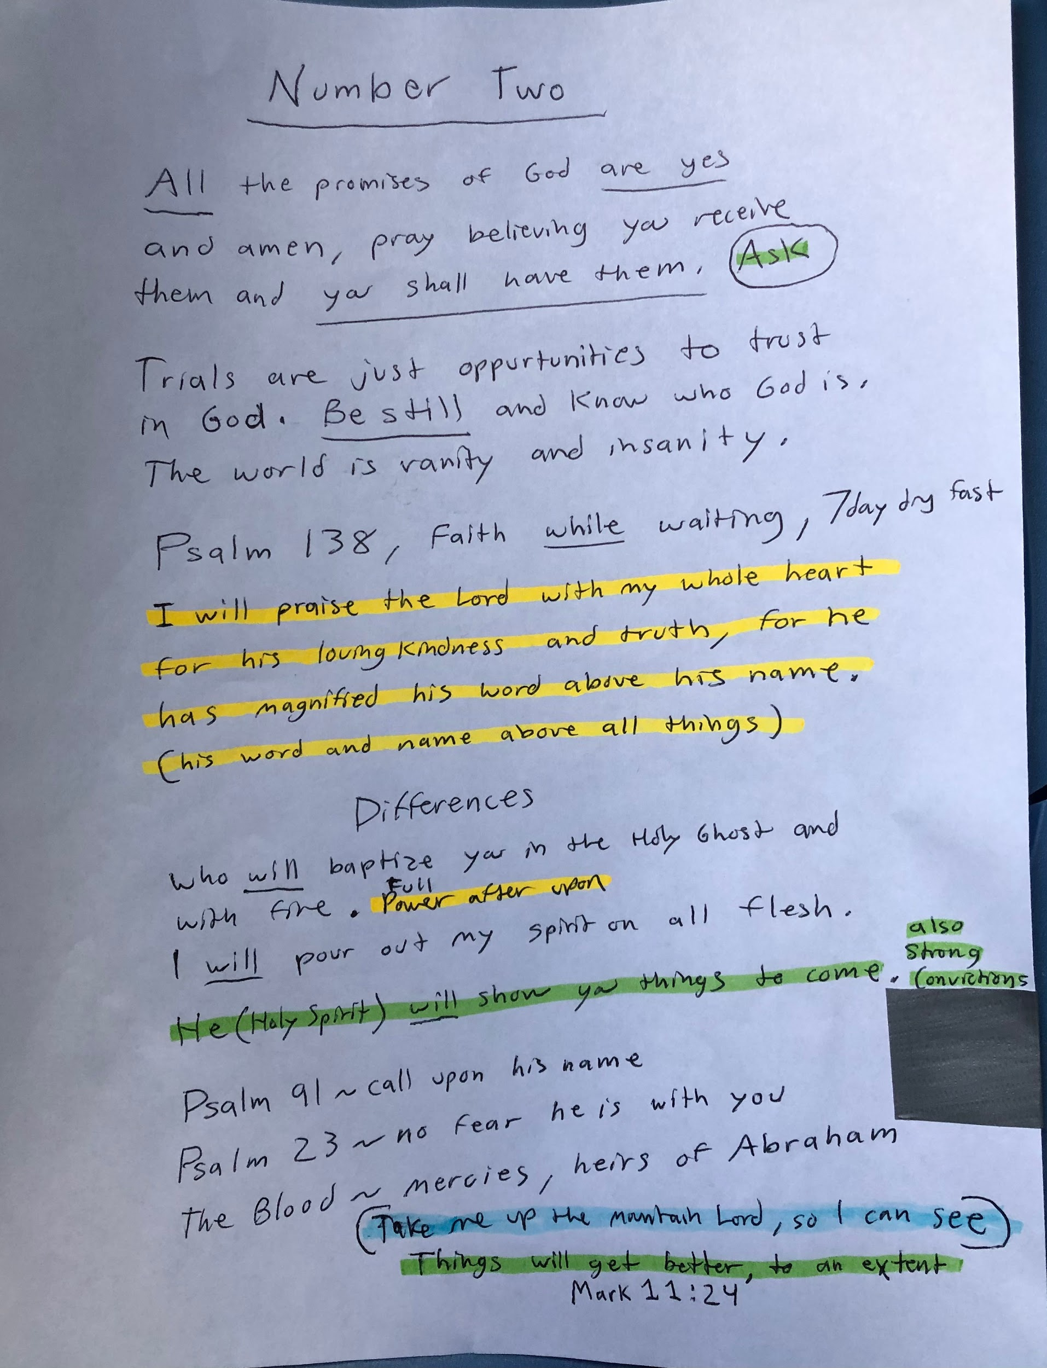
1 thing people don’t realize is that faith isn’t the all be it form of power. To have full power you must have the Holy Ghost and that requires something besides faith which is total surrender.
There is actually a price of consecration to have the Holy Ghost anointing. He can't fill someone full of themselves.
So people get hung up over faith when they need the Holy Spirit, he cant use an unclean selfish vessel
In essence faith is in full operation when the Holy Ghost is present
Somethings will still work not nearly as much
—-
7 days dry fasting (Purge)
Seek him with all your heart and you will find him,
Is one way to really tap into full manifestation of the Spirit
He is a rewarder of those who diligently seek him
It shall be as I have believed
Actively seek and wait, Roar (Fire, Vision)
Be like Enoch, live a life worth living
A Lot of people will cause problems in dark times and need of Holy Spirit to solve situations

Though i have everything if i don't seek God and surrender im useless
—-
Stop thinking things are gonna change when your not doing anything about it
Could be there last day repent
Juice Fasting and Thanksgiving is 90% of prayer power don't be fooled, Holy Ghost and Fire is best answer
What price would you pay for freedom? Fasting is essentially a burnt offering, not exactly a prayer but God still answers it. The enemy isn't going to back off until this age passes
“And Balaam said unto Balak, Build me here seven altars, and prepare me here seven oxen and seven rams.
And Balak did as Balaam had spoken; and Balak and Balaam offered on every altar a bullock and a ram.
And Balaam said unto Balak, Stand by thy burnt offering, and I will go: peradventure the Lord will come to meet me: and whatsoever he sheweth me I will tell thee. And he went to an high place.
And God met Balaam: and he said unto him, I have prepared seven altars, and I have offered upon every altar a bullock and a ram.
And the Lord put a word in Balaam's mouth, and said, Return unto Balak, and thus thou shalt speak.”
Seek him first, he is a rewarder of those who diligently seek him
If a man says he has faith but not works will his faith save him? Forgive that ye may be forgiven / Treat others how you want to be treated / If we confess our faults he is faithful and just to forgive us and cleanse us from all unrighteousness
Jesus said Father forgive them they know not what they do. On the other hand Paul said God will strike you also
All these things will come to pass, Even so come Lord Jesus
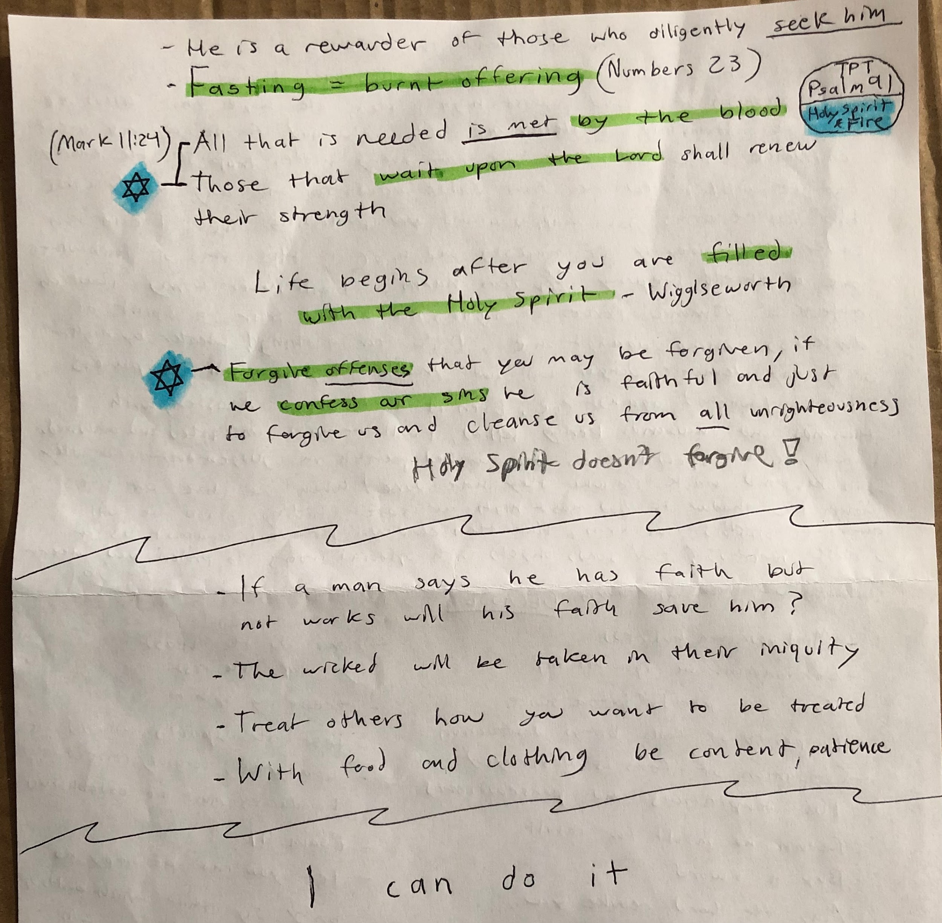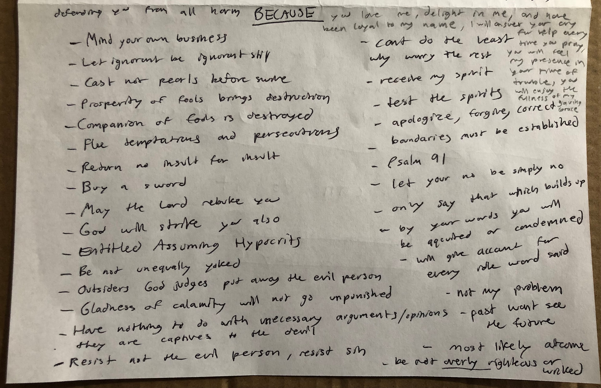

The Passion Translation
When you abide under the shadow of Shaddai,
you are hidden in the strength of God Most High.
He’s the hope that holds me and the stronghold to shelter me,
the only God for me, and my great confidence.
He will rescue you from every hidden trap of the enemy,
and He will protect you from false accusation and any deadly curse.
His massive arms are wrapped around you, protecting you.
You can run under His covering of majesty and hide.
His arms of faithfulness are a shield keeping you from harm.
You will never worry about an attack of demonic forces at night
nor have to fear a spirit of darkness coming against you.
Don’t fear a thing!
Whether by night or by day, demonic danger will not trouble you,
nor will the powers of evil launched against you.
Even in a time of disaster, with thousands and thousands being killed,
you will remain unscathed and unharmed.
You will be a spectator as the wicked perish in judgment,
for they will be paid back for what they have done!
When we live our lives within the shadow of God Most High,
our secret hiding place, we will always be shielded from harm.
How then could evil prevail against us or disease infect us?
God sends angels with special orders to protect you wherever you go,
defending you from all harm.
If you walk into a trap, they’ll be there for you
and keep you from stumbling.
You’ll even walk unharmed among the fiercest powers of darkness,
trampling every one of them beneath your feet!
For here is what the Lord has spoken to me:
“Because you loved me, delighted in me, and have been loyal to my name,
I will greatly protect you.
I will answer your cry for help every time you pray,
and you will feel my presence in your time of trouble.
I will deliver you and bring you honour.
I will satisfy you with a full life and with all that I do for you.
For you will enjoy the fullness of my salvation!”

Better Definition of sin

Vain Blameworthy Unwholesome Unbecoming
Ultimately Unsatisfying Crude

“Do not uproot the weeds” The phrase suggests a need for discernment and patience, allowing things to develop before taking drastic action to eliminate negativity, as doing so might cause unintended damage

To be fully led is to be filled with the Holy Ghost
The Spirit of Faith and of Power
Life begins after you are filled with the Holy Ghost get down and pray for power
Samson wasn’t thinking of scripture when he was defeating his enemies
7 DAY OR 3 DAY DRY FASTING w GROANING n TONGUES night glass
numbers 23
acts 1-2 Holy Spirit and Fire
seek him first, they work in vain if God didn’t purpose it
I’ll prophecy because I’m filled with the Spirit I’ll see visions because I’m filled with the Spirit
if we grieve him he does not remain
ministry starts with the Holy Spirit not because of outstanding faith
only way to make it through the last days

Then worry about Ephesians 1, Psalm 91 tpt, Romans 8
By the blood it is met, hallelujah Psalm 138

forgive offenses, no more revenge, let go, be patient, be content
Holy Spirit doesn’t forgive
if we confess our faults he is faithful and just to forgive us and cleanse us from all unrighteousness however that doesn’t mean we are exempt from all consequences
pray that ye enter not into temptation, cease without praying
present your bodies a living sacrifice, fasting is an act of repentance, bring body under subjection

if a man says he has faith but not works will his faith save him? even the demons believe and tremble
the wicked will be taken in their iniquity
who’s condemnation is justified?
he that endures to the end shall be saved
be content with food and clothing
be as patient with others as God is with you
in everything give thanks
who exalts themselves shall be humbled
abstain from every appearance of evil
looking - lust, saying - bitterness, disobedience - stealing
HEED the warnings
wrath is revenge, righteous indignation is protection and correction

who argues with a fool is one himself
cast not pearls before swine
have nothing to do with unnecessary destructive opinions and questions and arguments
entitled, assuming, hypocrites



