Hi-Lo DIRECTIONAL TRADING

1. Start with 1hr with the 4hr signal.
2. Check 30m chart with the 1hr signal,
3. Check 15m chart with the 30m signal,
4. Check 5m chart with the 15m signal,
5. Finally check 1m chart with the 5m signal.
Three major chart signals (4hr, 1hr and 30m) show direction UP (Blue dot) - 15m signal on 5m chart shows down.
1hr Chart shows 4hr signal of blue = UP 30m Chart shows 1hr signal of blue = UP
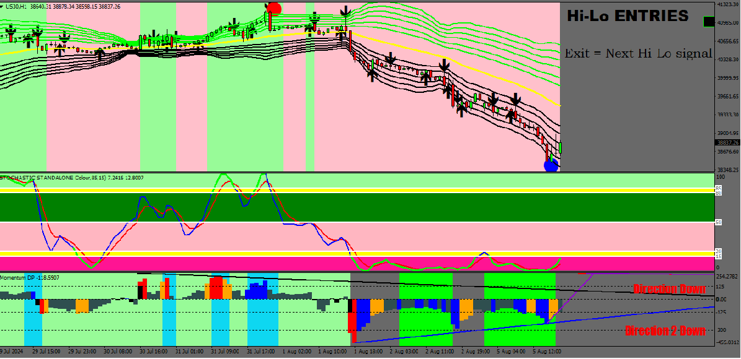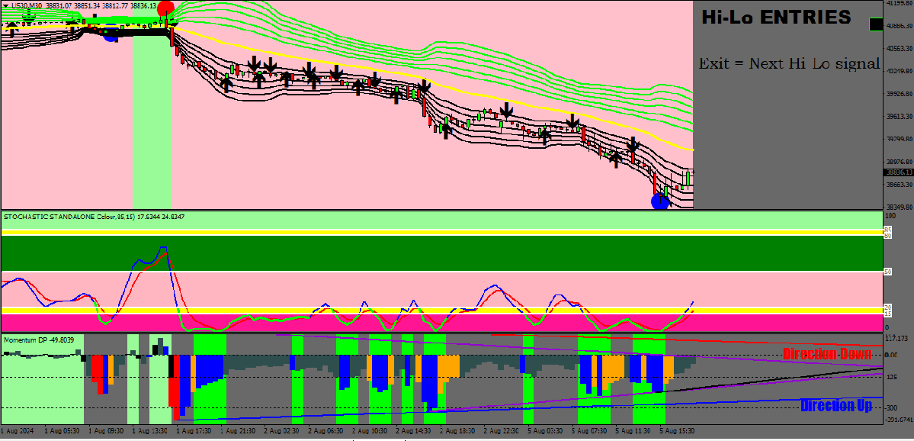
15m Chart shows 30m signal of blue = UP 5m Chart shows 15m signal of red = DOWN
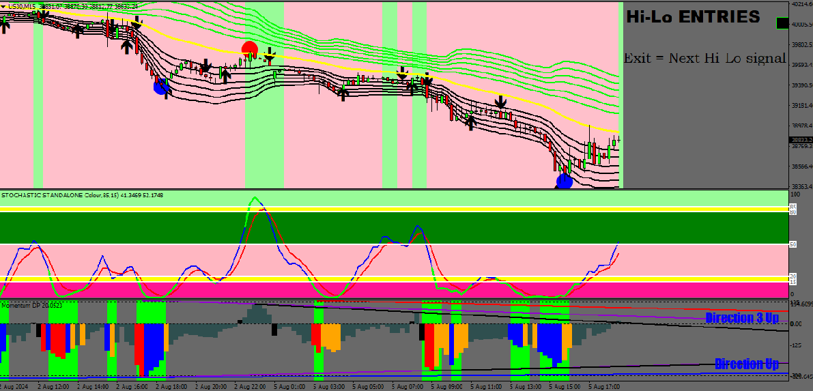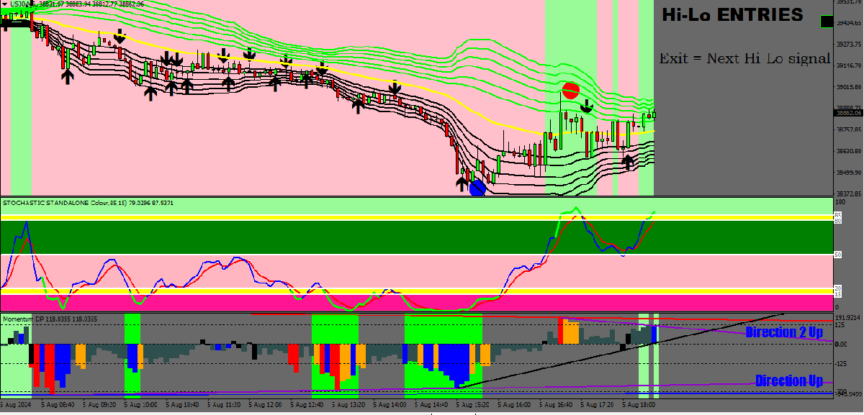

1M Chart shows 5m signal of red = DOWN
As there would have been some previous red signals the profit would still have been between 300-350pts - but taking the current exit signal profit is 482pts.
KNOWING THE CURRECT DIRECTION USING the Hi-Lo Trend indicator is a grail breakthrough for traders.


