Hello to every coders,
explanation:
TMA RED= tma 1H
TMA MAROON= tma 4H
Zero lag yellow= zero lag 4H
Input for TMA 1H
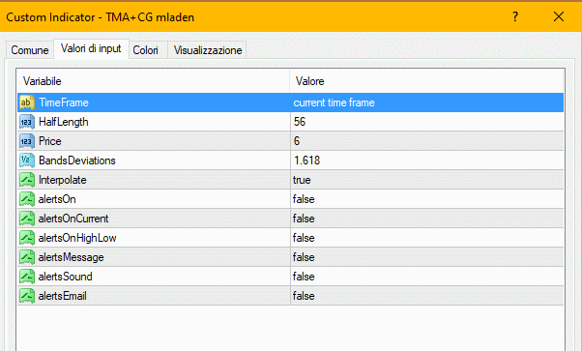

Input for TMA 4H
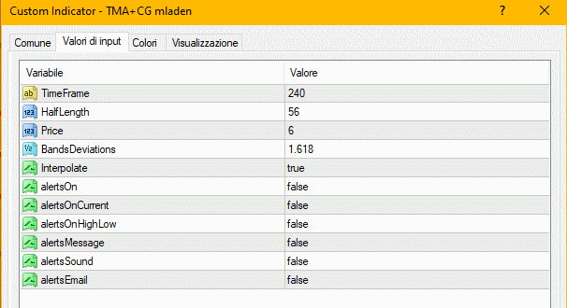
Input for ZERO LAG 4H
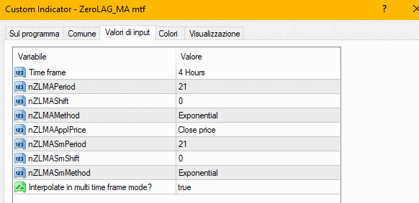
I would like to have the following indicator:
A) TMA 1H high band< TMA 4H low band and Zero lag 21 4H<TMA 4H low then cusp at 4
Or
B) TMA 1H high band < TMA 4H low band then cusp at 3
Or
C) Zero lag 21 4H<TMA 4H low band then cusp to 2
Or
D) TMA 1H low band < TMA 4H low band then cusp at 1

Example for A and B
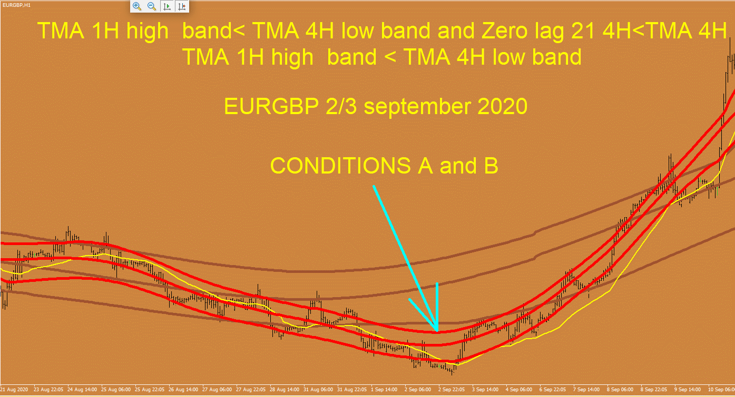

Example for D



