Gold Expert Advisor Trial Version Declaration
【Provideyour information before asking for the trial version ea】
1. You need to provide the server name of your dealer (as shown in the red circle in the figure)
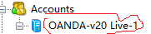
2. You need to provide the gold character of your trading account (as showninthefigure) >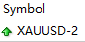
3. Provide your email.
【When you get the right to use, we will send you 2 files】
1. You need to apply for a VPS virtual cloud server and install MT4. If you makesure that your computer at home or office will not be powered off or disconnected, you can also install MT4 on your computer.No matter where you install it, you must ensure that this machine can’t be shut down or hibernated for a long time, your computer-OS need windows 10 or higher version.
2. A copy of ea with XAUF36.ex4 (the general probation period isautomatically expired for one week! You need to apply again when you need it)Place this file in the experts in your MT4 installation directory and restart MT4.
3. A copy of the template file with my_mode.tpl (Permanently used template),Place this file in thetemplates in your MT4 installation directory and restart MT4 , right click on the graph and you will see the template, select load template to load into your K-chart.
4. Your K-chart needs to load the time period of daily.h1.m30.m15.m5.m1,Click this , to divide the chart into 6 equal parts.
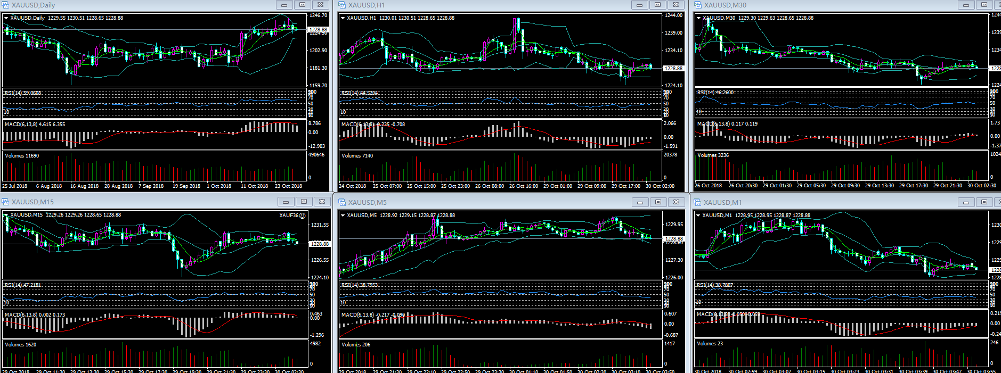
【File security】
We guarantee that wewill not be able to get your personal privacy in your computer. If you don't believe that you can install MT4 separately.
【Thank you. If you have any questions,please don’t hesitate to ask me. In order to enable you to gradually experience automatic trading and avoid the occurrence of risks, your funds can be gradually increased within your own acceptable range. Wish all passengers in F36 a pleasant journey and family happiness, happy auto-trading to making a lot USD.】

